Template for Preparation of WOC Full Paper
Margin 20 mm
Author first name Author last name*¹, Author2 first name Author2 last name²; ...
¹Department, Institution/Organization, City, Country
²Department, Institution/Organization, City, Country
Abstract
Full paper for the Proceedings of the WOC should be prepared by following these guidelines. This may be used as a template to ensure the correct format. A paper should be submitted in its final form with all tables, figures, and photographs embedded where they are appropriate. The file size of the manuscript should NOT EXCEED 10 MB. The absolute maximum length of the entire paper is 6 pages. Title in Arial 20 pt., bold. Subtitle 1. order in 11 pt. Abstract like all other text should be in Arial,10 pt. single-column format, fully justified, and not to exceed 400 words. Scientific names should be set to italic font like Liparis vestita. The * by an author denotes the corresponding author, underline marks the presenting author.
Margin 20 mm

Margin 20 mm

*Corresponding author’s Email: janedole@umc.edu (10 pt.)

Keywords: limit to five, list them alphabetically, separated by commas (10 pt.)

Introduction (Subtitle 1st order)
Start the two-column format here. Fully justified. Please use A4 size. After preparing the whole paper, you are required to submit the manuscript in MS-Word (.doc or .docx format) together with all figures and photographs as separate files in full resolution.

Name of the author(s) should be in line 2 under the paper title, followed by affiliations and contact information starting on line 3, all of which should be left-justified. In case there are co-authors, please place an * on the right side of the corresponding author and underline the presenting author.

Format (or Materials and Methods)
1) Paper (Subtitle 2nd order)
Papers should be single spacing and double-column format. Margins should be set to 2.0 cm from top, left and right edges, and 2.5 cm from bottom of the page.

1.1) Word usage (Subtitle 3rd order)
Please do not hyphenate words to break lines. Follow a writing style of common science papers which includes introduction, materials and methods, results, discussion, conclusion, acknowledgements, and references. Horticultural report, practical discussion and applied insight papers can follow the same format, with descriptive headings.

2) Font (Subtitle 2nd order)
Please use Arial. This font is universally available and has good “portability” when being transferred into a publishing software. Table 1 is a summary of formatting requirements.
Margin 25mm
Tables (or Results)
1) Tables (Subtitle 2nd order)
Tables should be centered and numbered consecutively (e.g. Table 1, Table 2, etc.) with a title at the top, fully justified. Contents of Tables should be in Arial font, 10 pt. Vertical lines are hardly needed; the same applies to unnecessary horizontal lines.

2) Format of tables (Subtitle 2nd order)
Table1. Font size and appearance, fully justified, to explain the Table. (Permission has been granted by William Cox to use the data. Source for data must be listed among the references.)

FontSize | Location in Paper | Appearance
20 | Paper Title | Title
12 | Name of Authors | Ryukyu, Hanako
11 | First level headings | INTRODUCTION
10 | Second and Third level headings | - Paper
10 | Body text | The paper
10 | Text of tables | The paper
10 | Figure and Table Title | Fig.1. Page margin
10 | Text in Abstract | Please follow
10 | Acknowledgements | Ocean Expo Park
10 | References | Ichihashi, S., Y.T. Wang, and A. Chang. (2024).

2.1) Placement of tables (Subtitle 3rd order)
Embed all Tables in the text where appropriate.
Authors are responsible for ensuring that all needed permissions have been secured for materials in the full paper, especially if previously published or taken from others.

Figures (or Discussion)
1) Figures (Subtitle 2nd order)
Figures, including photographs, should be put in digital files in .jpg, .tif, or .png with a resolution of 300dpi. Figures should be embedded in the paper and numbered consecutively (e.g. Fig.1, Fig. 2, etc.) with a title at the bottom, fully justified. Graphs and charts should be made in black-and-white, whereas photographs can be in color.

2) Figures showing graphs (Subtitle 2nd order)
Both axes must be clearly labeled legibly (including units if applicable). Authors are responsible for ensuring that all needed permissions have been secured for using their materials in figures, especially photographs.

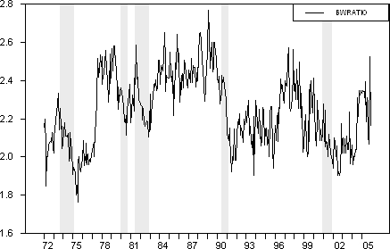
Fig.1. Title of figures should be fully justified. (Permission has been granted by George Green to use this graph. Source for such a graph must be listed among the references if applicable.)

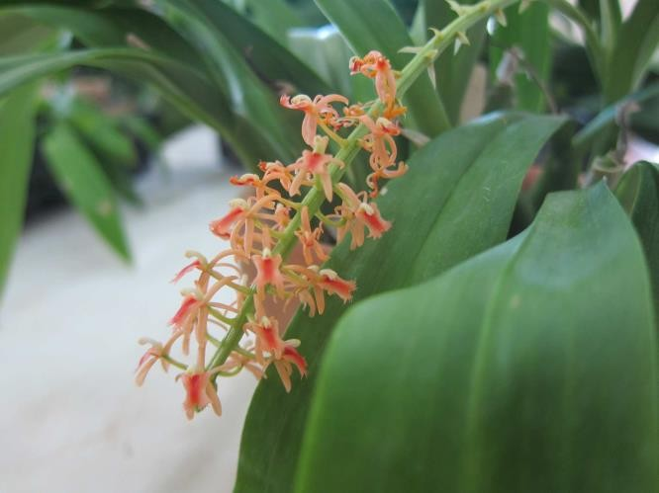
Fig. 2. Liparis vestita in full bloom. Scientific names like this should be set to italic font

Acknowledgements
Acknowledgements should be placed at the end of the paper, before the reference list. Fully justified.

References
All references listed should be cited in the text (Ichihashi, 1997; Islam et al., 2001; Tokuhara and Mii, 1993; Yen et al., 2011) and all citations in the text should be listed.
Start listing references here. Please observe and adhere to the following format.

Ichihashi, S. (1997). Orchid production and research in Japan. In: J. Arditti and A. M. Pridgeon (eds). Orchid Biology: Reviews and Perspectives, VII. p:171-212. Kluwer Academic Publishers.

Islam, M.O., S. Matsui, K. Iwao, and S. Ichihashi. (2001). Effects of light intensity and quality on the growth of callus and callus derived plantlets in Phalaenopsis. Proc. of Asia Pacific Orchid Conf. 7. p:86-88.

Tokuhara, K. and M. Mii. (1993). Propagation of Phalaenopsis and Doritaenopsis by culturing shoot tips of flower stalk buds. Plant Cell Rept. 13:7-11.

Yen, W.Y., Y.C. A. Chang, and Y.T. Wang. (2011). The acidification of sphagnum moss substrate during Phalaenopsis cultivation. HortScience 46:1022-1026.

